Fixing a bad merge/commit via Git Extensions
Situation 1: The bad merge/commit was caught immediately and there are no commits after the bad merge/commit that need to be maintained.
- Go to the branch that has the bad merge/commit.
- Go to the last commit on this branch that happened before the bad merge/commit.
- Create a new branch based off of the commit you found in step 2.
  - 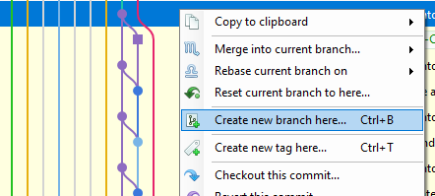
- Go to the new branch you just created.
- Verify that the new branch is correct and contains none of the bad commits.
- [DANGEROUS AND NOT REVERSIBLE] Delete the branch that contains the bad merge/commit. Then rename the new branch that you made to be the same name as the old branch.
Situation 2: There are commits that happened after the bad merge/commit that need to be maintained.
- Go to the branch that has the bad merge/commit.
- Go to the last commit on this branch that happened before the bad merge/commit.
- Create a new branch based off of the commit you found in step 2.
- Go to the branch you just created.
- Verify that the new branch is correct and contains none of the bad commits.
- Cherry pick any commits that happened after the bad merge/commit that you want to include in the new branch.
  - 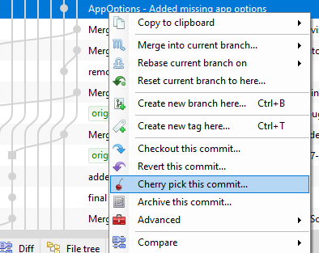
  - 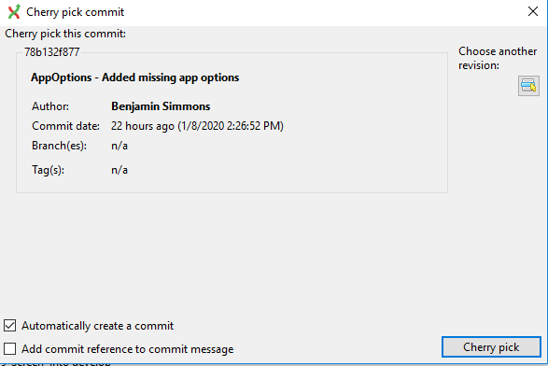
- Verify that the new branch contains all the commits you want and does not contain any of the bad commits.
- [DANGEROUS AND NOT REVERSIBLE] Delete the branch that contains the bad merge/commit. Then rename the new branch that you made to be the same name as the old branch.

